#### Hon. Dr. D. Y. Patil

Founder Chancellor

D. Y. Patil Deemed to be University Nerul, Navi Mumbai

### Registration Details

UG Students : 2900

**Online Registration Link**

**Training & Placement Cell – RAIT organizes**

**Hon. Dr.Vijay D. Patil**

Chancellor

1. Y. Patil Deemed to be University Nerul, Navi Mumbai

**Hon. Mrs. Shivani V. Patil**

Managing Trustee

D. Y. Patil Deemed to be University Nerul, Navi Mumbai

Since the seats are limited, registration will be on a First come fisrst serve basis.

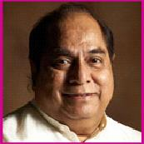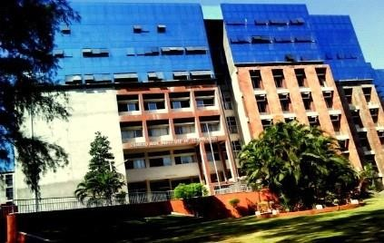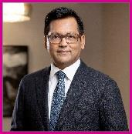

**One Month Internship cum Training**

**Program on EMPLOYABILITY SKILLS**

## 2 - 29 December 2019

### Organized by

**Training & Placement Cell**

**Ramrao Adik Institute of Technology Nerul, Navi Mumbai – 400706.**

**website:**[**www.rait.ac.in**](http://www.rait.ac.in/)

### Patron

Dr. Mukesh D. Patil Principal

**Convenor**

Dr. Amarsinh Vidhate Chief TPO

**Coordinator**

[**Email:**](mailto:rtcsp2019@rait.ac.in)

**Last date of registration: 30 November 2019**

**Payment Details**

**Account Details for Online Transfer**

Account Name: Bank and Branch : Account No:

IFSC Code:

Note: Carry NEFT payment slip for conﬁrmation of registration

**How to reach RAIT**

Ramrao Adik Institute of Technology (RAIT) is very close to Nerul and Juinagar Railway Station (Harbour line). The main campus is located in Nerul, along the Sion-Panvel Highway. The institute is reachable by State Transport buses, BEST and NMMT.

**About D.Y. PATIL GROUP**

The D.Y. Patil group strongly believes that world- class education is the stepping-stone to progress with its long-standing commitment towards quality teaching and learning. It has nurtured values that go into the making of successful careers. Equipped with state-of-the-art infrastructure, the group has a chain of many educational institutions that encourages individuals to think, question, explore and apply their well-honed minds to scale newer heights of success. It has gone much beyond, by venturing into areas like technology, architecture, legal studies, sports academy, management school, hospitality & catering school, etc. The very famous D.Y. Patil stadium ranks 6th in the world for its excellent infrastructure facility. Students are provided with special facility to pursue their chosen ﬁeld of activity like sports apart from academic within the campus.

# About R A IT

The institute is one of the oldest and ﬁnest colleges of Navi Mumbai, which was founded by the great philanthropist Dr. D.Y.Patil in the year 1983. RAIT provides state-of art amenities, combined with the experienced teachers and amicable environment. The college oﬀers a plethora of UG & PG courses including Electronics, Computer, Instrumentation, Information Technology and Electronics and Telecommunication Engineering. It is also one of the research Centre for Ph.D. program. The institute is aﬃliated to the University of Mumbai. It is recognized by DTE, AICTE and accredited by NAAC & NBA, paving way for a promising future. It has carved a niche for itself in several spheres of activity which includes academics, technical expertise, extracurricular activities (Horizon, Sports, Kalaraag etc). RAIT is located in the lush green campus of D. Y. Patil Vidyanagar & proximity to the Mumbai – Pune Express Highway makes it easily accessible.

# About TPC – RAIT

The Training and Placement Department provides active assistance in researching prospective employers and in the interviewing, resume creation, aptitude training and networking skills that are essential to make the best match. It is a matter of immense pleasure and pride that our students are able to make a choice of employment even before they graduate. Our task is to make it possible. Our mission is to provide the best of the employment available.We organize recruiting events on and off campus for large number of reputed organizations each year, including Morgan Stanley, JP Morgan Chase, Reliance Jio, TCS, Ericsson, LnT Infotech, ZTE, Mahanagar Gas, Infosys, HCL tech, Tech- Mahindra , Atos india, Indian navy, Schneider-electric and the list is endless. The recruitment year kicks off towards the start of the final year, when companies descend upon RAIT to make pre-placement presentations about their organizations as well as to recruit the students.

# Major TOPICS

### DATA STRUCTURES.

* + **Algorithms.**
  + **DBMS.**
  + **Java.**
  + **Internship Project.**
  + **Aptitude.**
  + **Soft – Skills.**
  + **Group Discussion.**
  + **Personal Interviews.**